**HEALTH CARE MANAGEMENT SYSTEM**

**Submitted in the partial fulfillment of the requirement**

**MASTER OF COMPUTER APPLICATION (MCA)**



**PROJECT SYNOPSIS**

**Under the Guidance of : Submitted by:**

**Jitendra Kumar Sinha Name :**

**Sr. faculty –Nalanda College Reg.No :**

**Bihar Sharif , Nalanda Session : 2017-2020**

**Recognized Study Centre**

**Nalanda College , Bihar Sharif**

**Under**

**Magadh University , Bodh Gaya**

**ACKNOWLEDGEMENT**

At the outset, I am offering gratitude to my guide, who gave me great in right into what had to be done, and for their encouragement, without which it couldn’t have been possible to complete this project.

I am indicated to my friends for help me to prepare this project and for several useful suggestions.

I would also like to thanks to every one of the organization who helped me in preparing this project & who guided me & gave me many useful suggestions by time to time in resolving difficulties.

I hope that my efforts on the project will fully satisfy expects who will examine this project. I pray god to give me success & brilliance in the field of computer it’s my first opportunity by Magadh University, so very thankful to give me first golden occasion in my life. And I will be eager to work on various projects Thanks to all.

Name :

Course : MCA

Reg.No :

**INTRODUCTION OF PROJECT**

The project “Health Care Management System” includes registration of patient, storing their details into system & also computerized billing of pharmacy and labs. The software has the facility to give unique ID for every patient and stores the details of every patient and staff automatically. It includes a search facility to know the current status of each room. The users can search availability of doctor and the details of patient using the ID.

The Hospital Care Management System can be entered using a username and password. It is accessible either administrator or receptionist. Only they can manipulate the data in the software storage location. The data can be retrieved easily and efficiently. The interface is user friendly. The data is well protected for personal use and makes the data processing very fast.

The Hospital Care Management System is powerful, flexible and easy to use and is designed and developed to deliver real conceivable benefits of hospital.

The Hospital Care Management System is designed for multi-speciality hospital to cover a wide range of hospital administration and management processes. It is an integrated end-to-end Hospital Care Management System the provides relevant information about the hospital to support effective decision making for patient care, hospital administration, critical financial accounting in a seamless flow.

Hospital Care Management System is a software product suite designed to improve the quality and management of hospital in the area of clinical process analysis and activity based costing. Hospital Care Management System enable you to develop your organization and improve its effectiveness and quality to work.

**OBJECTIVITY OF PROJECT**

The Hospital Care Management System having a number of objectivity and all of them being fulfilled in this project. The following objectives of the project is –

1. It defines the working of the hospital
2. It keep recording of information about the patient that come
3. It contains the feature to generate bills
4. It keep recording of information related to diagnosis given to the patient
5. It keeps information related to immunization provided to children or patient.
6. It keep information about the various disease and medicines available to cure them.

**CURRICULUM VITAE OF GUIDE**

**Jitendra Kumar Sinha** **Location : Bihar Sharif Telephone: 9709692188** **Email: jeetartiarab@gmail.com**

**Professional Profile**

‘Accomplished IT support Analyst with a background in 1st& 2nd Line IT support provision across public and private sector organization as well as extensive infrastructure project experience.’

With broad ranging IT support experience coupled with a robust understanding of IT infrastructure and environments within large organization . I confidently deliver support solution that ensure optional levels of IT service performance and swift resolution of issues and queries.

I posses a deep technical knowledge across business systems including hardware, software ,networking & change methodology

**Core Skills**

* Software & Hardware trouble Shooting
* Windows & Linux Environment
* Server performance management
* IT security Management
* Web site Management

**Carrier Summary**

Nov-2001-jan 2002 web site Developer in Tech book Electronics, New Delhi

Feb 2002- Dec 2003 Sr. Faculty in NIIT , New Delhi

Jan 2004- Sr. Faculty in Nalanda college

Director Nalanda software solution Bihar Sharif

**Education , Vocational Qualification**

* Graduation in Chemistry from Patna University
* MCA from IGNOU , New Delhi
* PGDBM from IIBM , Patna
* Pre PHD from MU, Bodh Gaya

**Technical Knowledge**

* Windows Server
* Active Directory
* Firewall Management
* Desktop/ Laptops

**Software Known**

* Java, .Net, PHP, Python, C++, Script Languages
* Oracle, Sybase
* Windows , Linux

**Personal Information**

**Father’s Name :** Late Binay Kumar Sinha

**Address :** Kashitakiya, Near Model School

Bihar Sharif, Nalanda (803101)

**Blood Group :** B+

**Hobies**  **:** Programming , Planting, Listing Music

Attending seminar, Active in NGO Work

Date :

Place : (Signature)

Jetendra Kumar Sinha**STUDENT PROFILE**

**PROJECT INFORMATION**

Name Rohit Kumar

Reg No. 1426300684

Course name MCA

Study centre Nalanda College

Project category Web Application

Software used HTML, CSS, XML, JavaScript

**GENERAL INFORMATION**

Father’s name

Address

Qualification MCA Aspirant

Contact No.

E-mail

Blood group

Hobbies Programming, Planting

PLACE:…………………….

DATE:-……………………..

SIGNATURE

**STUDENT PROFILE**

**PROJECT INFORMATION s**

Name Vikrant Kumar

Reg No. 1425801360

Course name MCA

Study centre Nalanda College

Project category Web Application

Software used HTML, CSS, XML, JavaScript

**GENERAL INFORMATION**

Father’s name

Address

Qualification MCA Aspirant

Contact No.

E-mail

Blood group

Hobbies Programming, Planting

PLACE:…………………….

DATE:-……………………..

SIGNATURE

**MODULES OF PROJECT**

1. **Administrator Module**

▪  Manage department of hospitals, user, doctor, nurse, pharmacist, lab accounts.

▪  Watch appointment of doctors

▪  Watch transaction reports of patient payment

▪  Bed ,ward, cabin status

▪  Watch blood bank report

▪  Watch medicine status of hospital stock

▪  Watch operation report

▪  Watch birth report

▪  Watch diagnosis report

▪  Watch death report

**2. Patient Module**

▪   View appointment list and status with doctors

▪  View prescription details

▪  View medication from doctor

▪  View doctor list

▪  View blood bank status

▪  View operation history

▪  View admit history. like bed, ward icu etc

▪  Manage own profile

**3. Doctor Module**

▪  Manage patient. account opening and updating

▪  Create, manage appointment with patient

▪  Create prescription for patient

▪  Provide medication for patients

▪  Issue for operation of patients and creates operation report

▪  Manage own profile

**4. Nurse Module**

▪  Manage patient. account opening and updating

▪  Allot bed, ward, cabin for patients

▪  Provide medication according to patient prescription

▪  Manage blood bank and update status

▪  Keep record of patient operation, baby born and death of patient

**5. Pharmacist Module**

▪  Maintain medicine

▪  Keep records of hospitals stock medicines and status

▪  Manage medicine categories

▪  Watch prescription of patient

▪  Provide medication to prescriptions

6. **Lab Module**

▪  Watch prescription list

▪  Upload diagnostic report

▪  Preview of report files. like xray images, ct scan, mri reports

▪  Manage own profile

7. **Accountant Module:**

▪  Create invoice for payment

▪  Order invoice to patient

▪  Take cash payment

▪  Watch payment history of patients

▪  Manage own profile

**DATA FLOW DIAGRAM (DFD)**

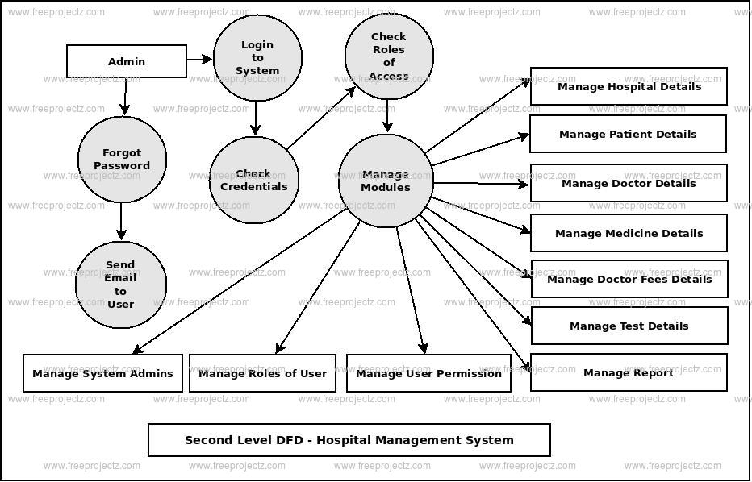

**ENTITY RELATIONSHIP DIAGRAM**

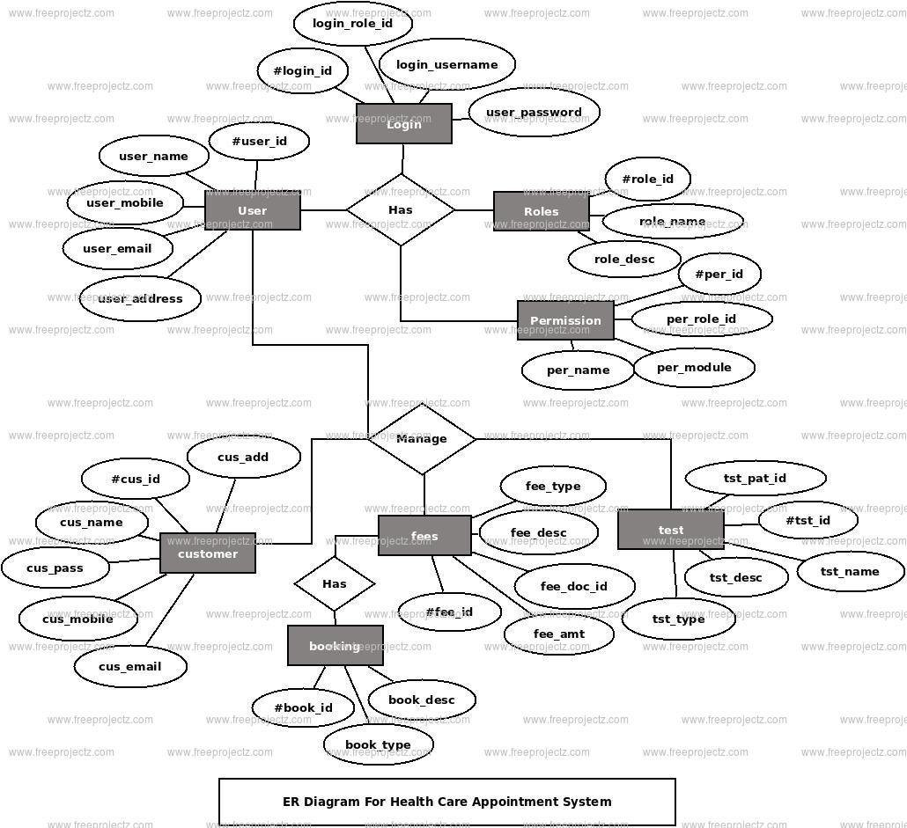

**SCOPE OF THE PROJECT**

The Health Care Management System having a number of scope in health industry. Some of them are illustrated that is-

1. The information about the patient is dine by just writing the patient name, age and gender. Whenever the patient comes up his information is stored freshly.
2. The bills are generated by the recording price for every facility provided to patient on a separate sheet and at last they all are summed up.
3. The diagnosis information to patients is generally recorded on the document which contains patient information.
4. The immunization records of children are maintained in pre-formatted sheets, which are kept in a file.
5. The information about various diseases is not kept as any document. Doctors themselves do this job by remembering various medicines.

All the work done manually by the receptionist and other operational staff and lot of papers are needed to handle. This software decreases the work load as well as wastage of paper and time.

**LIMITATION OF THE PROJET**

1. It is time consuming as lot of time is wasted in searching and sorting of duty data
2. Poor security and data protection
3. There is a lot of scope for misplacement of checkup files
4. Patients should wait for longer time
5. The high cost of material for the project and the everyday constraint increaes in transportation tax during data collection affected the research work.
6. The datacollection from the staff is cubersome.